

ITA_User Instruction Manual

Export/Import

*－*Version 1.4*－*

Copyright © NEC Corporation 2019. All rights reserved.

Disclaimer

All the contents of this document are protected by copyright owned by NEC Corporation.

Unauthorized reproduction or copying of all or part of the contents of this document is prohibited.

The contents of this document are subject to change without prior notice in the future.

NEC Corporation is not responsible for any technical or editorial errors or omissions in this document.

NEC Corporation do not guarantee accuracy, usability, certainty of the content in this document.

Trademark

* Linux is registered trademark or trademark of Linux Torvalds, registered in the U.S. and other countries.
* Red Hat is registered trademark or trademark of Red Hat,Inc. Registered in the U.S. and other countries.
* Apache, Apache Tomcat, and Tomcat are registered trademarks or trademarks of the Apache Software Foundation.
* Ansible is registered trademark or trademark of Red Hat,Inc.
* AnsibleTower is registered trademark or trademark of Red Hat,Inc.

The names of other systems, company name and products mentioned in this document are registered trademarks or trademarks of their respective companies.

The® mark and TM mark are not specified in this document.

※ 「Exastro IT Automation」 is written as 「ITA」 in this document.

**Table of Contents**

Introduction 3

1 Overview of Export/Import 4

2 Menu and screen configuration of Export/Import 5

2.1 Menu List 5

3 Function and operation method 6

3.1 Export Menu 6

3.2 Import menu 8

3.3 Export/Import menu list. 10

3.4 Export Symphony/Operation 11

3.5 Import Symphony/Operation 12

3.6 Export / Import Symphony/Operation list 14

4 Remarks 15

4.1 About the data that can be retrieved by Export Symphony/Operation 15

4.1.1 Export Symphony 15

4.1.2 Export Operation 19

Introduction

This manual describes the function and the way to operate the Export/Import function in ITA.

# Overview of Export/Import

This chapter introduces the function and the way to operate the Export/Import function.

In Export/Import, the following two method to migrate data is available.

(1) Menu

Select the ITA menu to migrate and migrate the menus by overwriting the data in the unit of menu.

ITA server A

Kym file

Import

Export

Kym file

ファイル

ITA server B

**Selected menus**

Menu A

Menu Ｂ

ﾒﾆｭｰC

Menu C

Menu Ｂ

ﾒﾆｭｰC

Menu C

Menu A

(2) Symphony／Operation

Select the Symphony and the operation to migrate, and migrate them by overwriting the data associated with them. Please refer to “ 4.1 About the data that can be retrieved by Export Symphony/Operation” for the details of the associated data.

Selected data

Selected data

Associated data

Input operation list

Symphony List

Menu B

ﾒﾆｭｰB

**Selected Symphony, Operation and associated data**

Associated data

Selected data

Associated data

ITA Server B

Kym2 file

ファイル

Export

Import

Kym2 file

Menu A

Input operation list

Symphony List

Menu B

ﾒﾆｭｰB

Selected data

Associated data

Menu A

ITA Server A

# Menu and screen configuration of Export/Import

This chapter describes the menu and screen configuration of Export/Import.



## Menu List

The menus of Export/Import are as follows.

**Table 2-1 ITA menu list**

|  |  |  |  |
| --- | --- | --- | --- |
| **No** | **Menu group** | **Menu / Screen** | **Description** |
| 1 | Export/Import | Export menu | Export the data of menu. |
| 2 | Import menu | Import the data of menu. |
| 3 | Export/Import menu list | Manage the status of the exportation executed in [Export menu] and importation executed in [Import menu]. |
| 4 | Export Symphony/Operation | Export the data associated with Symphony and Operation. |
| 5 | Import Symphony/Operation | Import the data exported in [Symphony/Operation] menu. |
| 6 | Export/Import Symphony/Operation list | Manage the status of the exportation executed in [Export Symphony/Operation] and importation executed in [Import Symphony/Operation]. |

# Function and operation method

## Export Menu

Export data registered in the ITA system in each menu.

※When moving data to another ITA environment, the integrity of data may corrupt if the whole menu is not moved together.

1. Select the menu to export

##### C:\Users\113414A009FT8\Desktop\20160220131903.png



Figure 3‑1 Export menu screen(1)

1. Click the export button after selecting the menu.

The execution number of export operation is displayed, so please check the status of execution in the "Export/Import menu list" screen.



Figure 3‑2 Export menu screen(2)

## Import menu

Import the data exported in [Export menu] menu.

1. Select the file to be imported then click the [Upload] button. 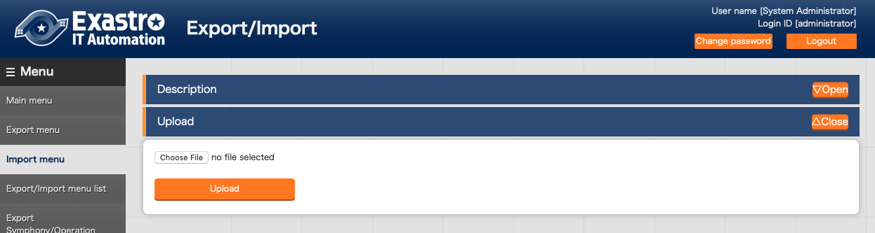

Figure 3‑3 Menu import screen(1)

1. The list of the menu in the imported file is displayed. Select the menu to import then click the [Import] button. Please click [Import (without discarded data)] to import the menu without discarded data.

The menu whose checkbox is checked will be imported.  
Please uncheck the menus that are not needed to be imported.

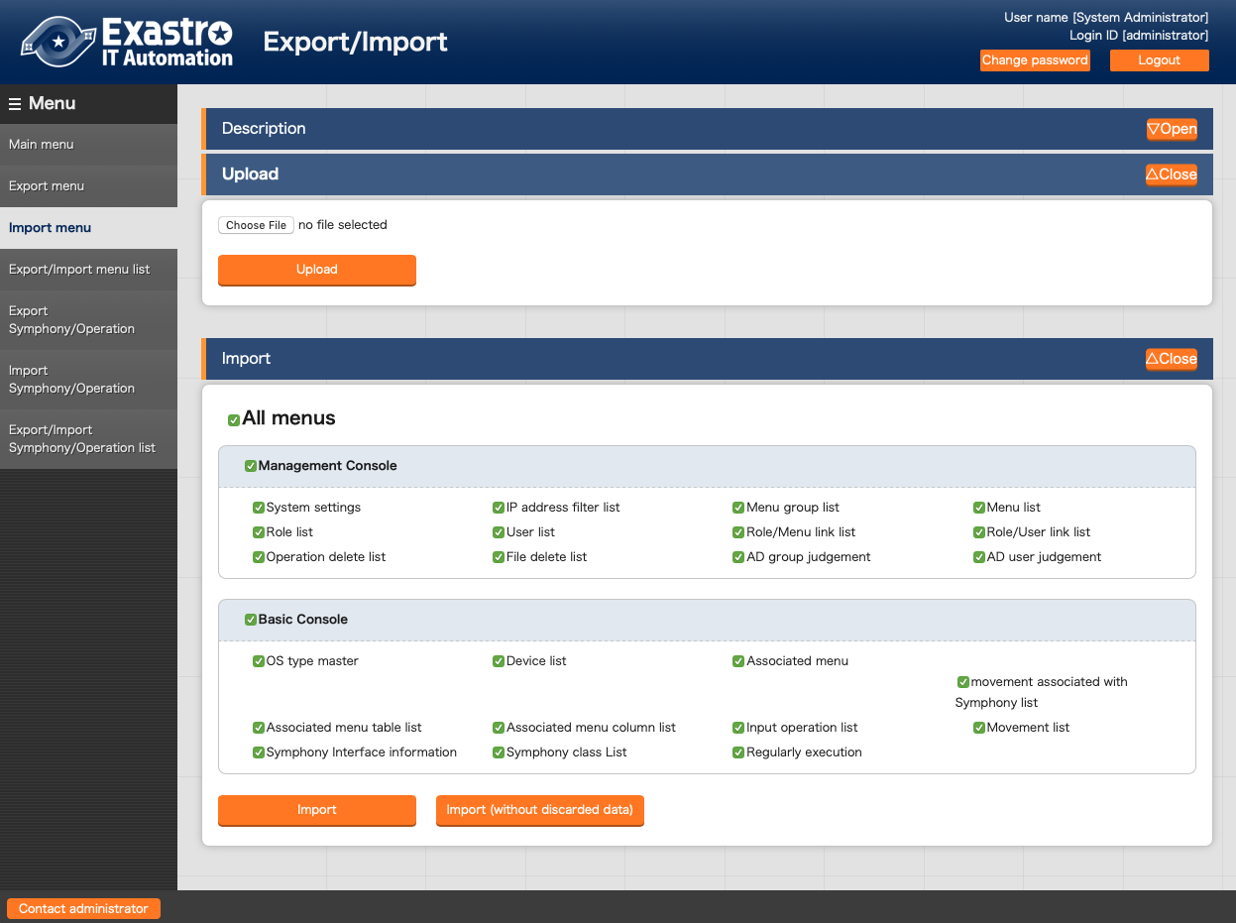

Figure 3‑4 Import menu screen(2)

1. Move to the registration menu. Users can check the status of the migration in the [Export/Import menu list] by clicking the [Export/Import data list] button.

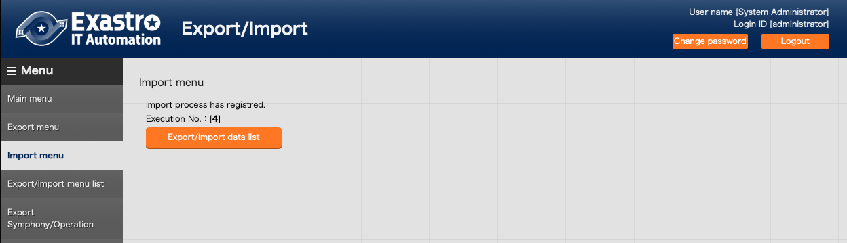

Figure 3‑5 Menu import screen(3)

## Export/Import menu list.

Manage the status of the exportation executed in "Export menu" and importation executed in [Import menu].

The status will change in the order of "Unexecuted", "Executing", "Completed".

The execution type will display "Export" or "Import".

The import type will be "Normal" or "Without discarded data" if the execution type is import.

Please click the filter button and confirm that the status is "Completed".

In the case of export, if the status is "Completed", the exported data will be displayed in the "File name" column. Please download and use it. In the case of import, the imported data will be displayed in the "File name" column.

If error occurred during import execution, the status will become "Completed (error)".

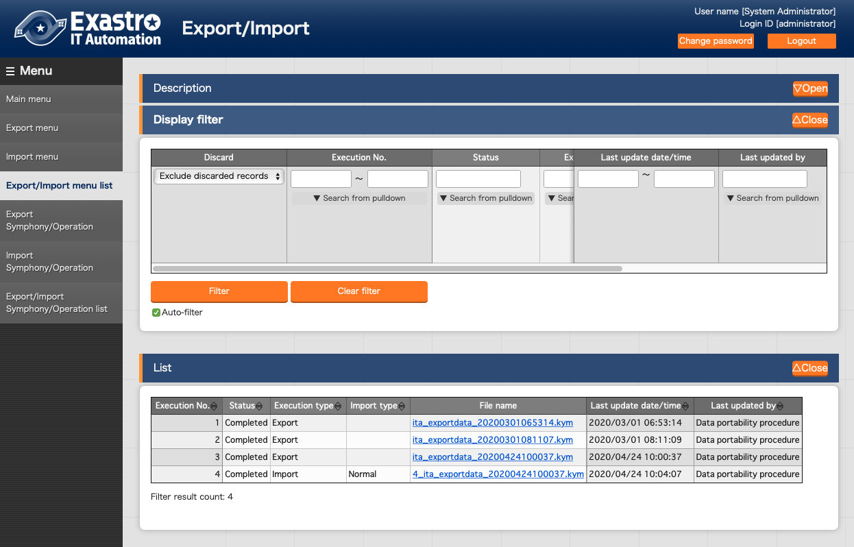

Figure 3‑6 Export/Import menu list

Table 3‑1　List screen item list（Export/Import menu list）

|  |  |
| --- | --- |
| Item | Description |
| Execution No. | Auto generated unique number. |
| Status | Changes in the order of "Unexecuted", "Executing", "Completed".  If error occurred during execution, the status will become "Completed (error)". |
| Execution type | Export or Import |
| Import type | If the Execution type is “Import”, “Normal” or “Import (without discarded data)” will be displayed. |
| File name | In the case of export, if the status is "Completed", the exported data will be displayed in the "File name" column. Please download and use it.  In the case of import, the imported data will be displayed in the "File name" column. |

## Export Symphony/Operation

Specify Symphony or operation and export the data associated with it.

For information about the associated data, please refer to “ 4.1 About the data that can be retrieved by Export Symphony/Operation”.

This function is assumed to be used for exporting data from one ITA environment and then import the data into another ITA environment.

While “Export menu” exports the data of the whole menu, this function exports data in the unit of associated.

1. Select the Symphony and Operation to export and click the “Export” button.

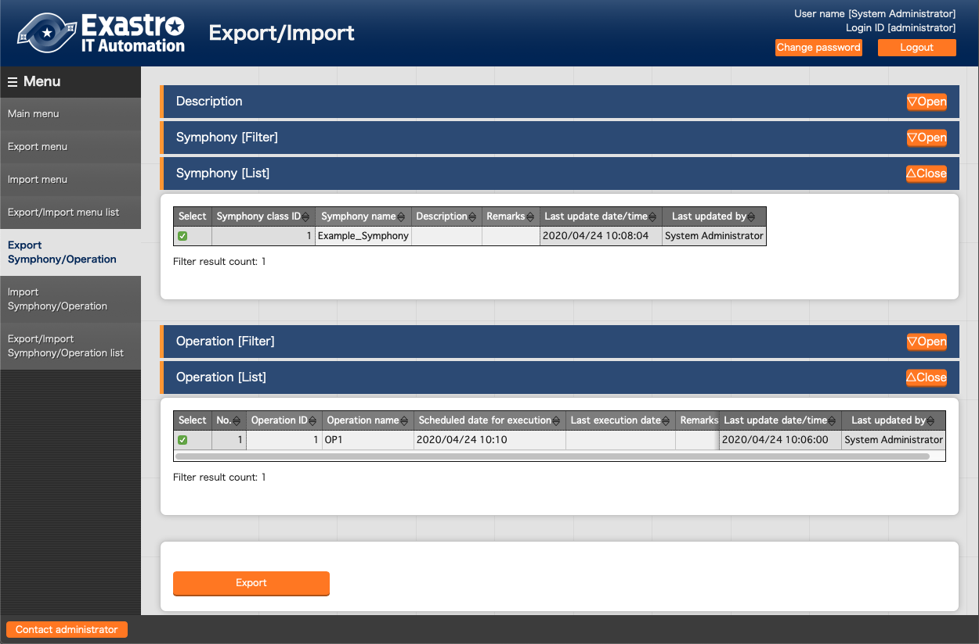

**Figure 3‑7 Export Symphony/Operation(1)**

1. Move to the registered screen. Click the 「Export/Import Symphony/Operation list」 button, then the screen moves to the 「Export/Import Symphony/Operation list」 menu. Users can check the status of exportation and retrieve exported data.

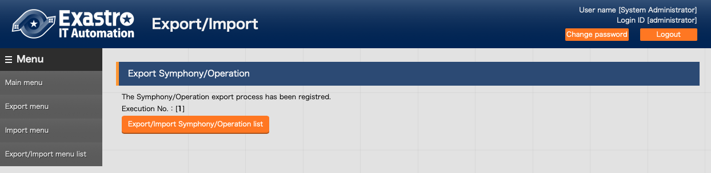

**Figure 3‑8 Export Symphony/Operation(2)**

## Import Symphony/Operation

Import the data exported in [Export Symphony / Operation] menu.

※The data to be imported is imported using the unique item of the data as a key (the numerical value at the left end of the table). If data of the unique item already exists, existing data will be overwritten.

※The last modified person of the data after the import will be the user who executed the import.

※For example, in this function it is assumed that data registered in the A environment is exported, and imported into the B environment to execute work. If users edit the data after importing into the B environment, each function may not work properly.

1. Select the file to import then click the “Upload” button.

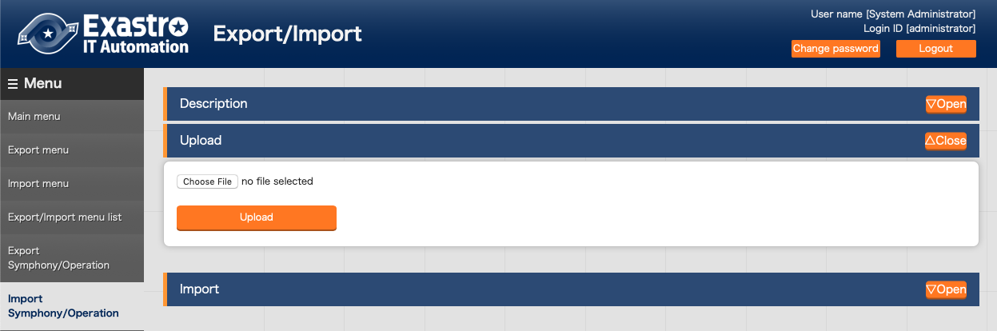

**Figure 3‑9 Import Symphony/Operation (1)**

1. List of Symphony and Operation in the imported file is displayed. Select the Symphony and operations to import and press the “Import” button.

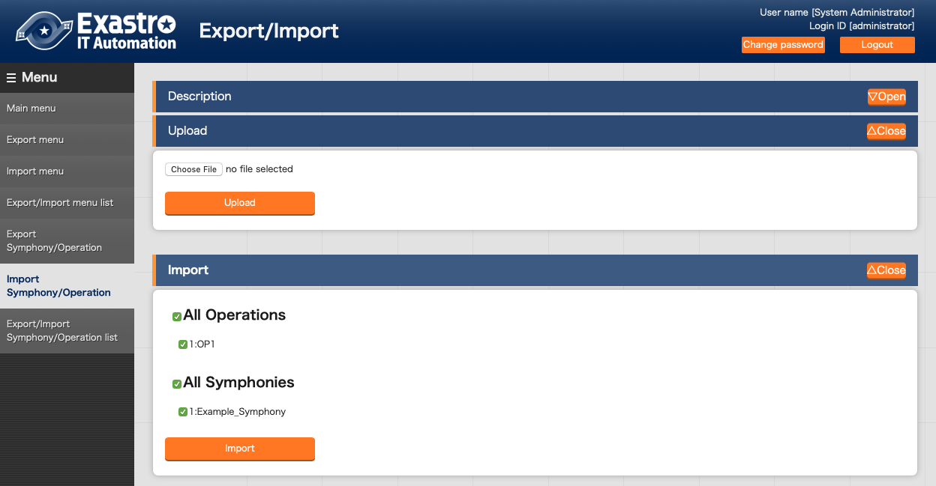

**Figure 3‑10 Import Symphony/Operation(2)**

1. Move to the registered screen. Click the 「Export/Import Symphony/Operation list」 button, then the screen moves to the 「Export/Import Symphony/Operation list」 menu. Users can check the status of importation.

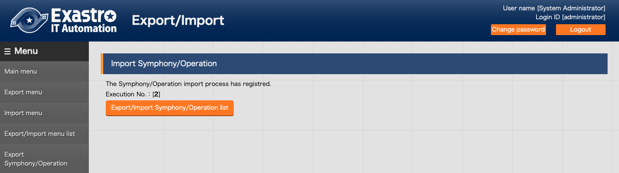

**Figure 3-11 Import Symphony/Operation(3)**

## Export / Import Symphony/Operation list

Manages the status of exports performed in the [Export Symphony /Operation] menu and the status of imports performed in the [Import Symphony /Operation] menu.

The status changes in the order of “Unexecuted”, “Executing” and “Completed”.The processing type displays 「Export」or 「Import」.When Export is “Completed”, the exported data will be displayed in “File name” column. Please download and use it. In the case of import, the imported data is displayed in “File name” column.

The ID of selected Symphony and Operation are displayed in “Remarks”.

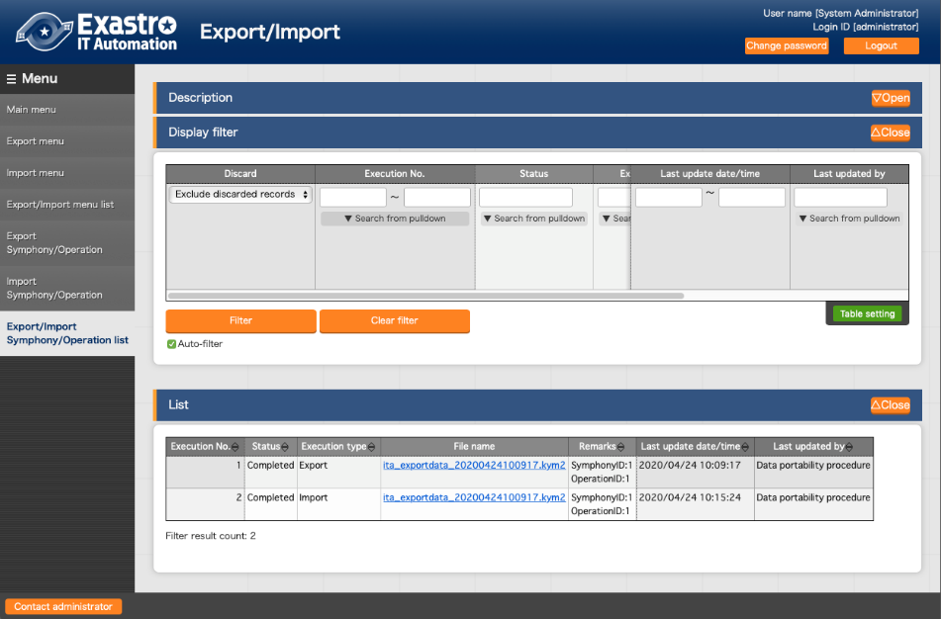

**Figure 3‑12 Export/Import Symphony/Operation list**

The list of the items in the screen are as follows.

**Table 3‑2 List screen item list（Export/Import Symphony/Operation list）**

|  |  |
| --- | --- |
| Item | Description |
| Execution No. | Auto generated unique number. |
| Status | Changes in the order of "Unexecuted", "Executing", "Completed".  If error occurred during execution, the status will become "Completed (error)". |
| Execution type | Export・・・Export Symphony/Operation  Import・・・Import Symphony/Operation |
| File name | In the case of export, if the status is "Completed", the exported data will be displayed in the "File name" column. Please download and use it.  In the case of import, the imported data will be displayed in the "File name" column. |
| Remarks | The ID of the selected Symphony and Operation are displayed. |

# Remarks

## About the data that can be retrieved by Export Symphony/Operation

The data acquired by Export Symphony/Operation is retrieved by following the linked menu. The link of each menu is as follows.

### Export Symphony

|  |
| --- |
| **Movement details** |
| (PK)Associated item No. |
| Movement |
| Playbook file |
| ・・・ |

|  |
| --- |
| **Template list** |
| (PK) file ID |
| Template embedded variable name |
| ・・・ |

|  |
| --- |
| **Template list** |
| (PK) file ID |
| Template embedded variable name |
| ・・・ |

|  |
| --- |
| **File list** |
| (PK) file ID |
| File embedded variable name |
| ・・・ |

**Ａｎｓｉｂｌｅ-Legacy**

**The specified SymphonyID**

Hidden menu

|  |
| --- |
| **Movement variable association list** |
| (PK)Associated item No. |
| Movement |
| Variable name |
| ・・・ |

Hidden menu

|  |
| --- |
| **variable name list** |
| (PK) number |
| ・・・ |

１:playbook

|  |
| --- |
| **Symphony class list** |
| Symphony class ID |
| ・・・ |

|  |
| --- |
| **Movement list** |
| (PK)MovementID |
| ・・・ |
|  |
|  |
|  |
|  |
|  |

|  |
| --- |
| **Playbook file** |
| (PK) file ID |
| Playbook file |
| ・・・ |

Hidden menu

|  |
| --- |
| **List of common variables usage** |
| (PK)No |
| File Type |
| Primary key |
| Variable name |
| ・・・ |

|  |
| --- |
| **Global variable list** |
| (PK) number |
| Global variable name |
| ・・・ |

|  |
| --- |
| **File list** |
| (PK) file ID |
| File embedded variable name |
| ・・・ |

**Ａｎｓｉｂｌｅ-Pioneer**

**Ａｎｓｉｂｌｅ-LegacyRole**

**DSC**

**OpenStack**

Hidden menu

|  |
| --- |
| **Movement associated with Symphony list** |
| (PK)Movement Class ID |
| Symphony Class No |
| Movement ID |
| ・・・ |

**Ａｎｓｉｂｌｅ-Pioneer**

|  |
| --- |
| **Movement details** |
| (PK)Associated item No. |
| Movement |
| Dialogue type |
| ・・・ |

|  |
| --- |
| **Dialog files** |
| (PK)file ID |
| Dialogue type |
| OS type |
| ・・・ |

|  |
| --- |
| **Dialogue type list** |
| (PK) Item No. |
| Dialogue type |
| ・・・ |

Hidden menu

|  |
| --- |
| **Movement variable association list** |
| (PK) associate item number |
| Movement |
| Variable name |
| ・・・ |
| Variable name |
| ・・・ |

1: Dialogue file

Hidden menu

|  |
| --- |
| **Variable name list** |
| (PK) Item No. |
| ・・・ |

Hidden menu

|  |
| --- |
| **List of common variables usage** |
| (PK)No |
| File Type |
| Primary key |
| Variable name |
| ・・・ |

|  |
| --- |
| **OS type master** |
| (PK)OS type ID |
| ・・・ |

|  |
| --- |
| **Global variable list** |
| (PK) Item No. |
| Global variable name |
| ・・・ |

|  |
| --- |
| **Template list** |
| (PK) file ID |
| Template embedded variable name |
| ・・・ |

|  |
| --- |
| **File list** |
| (PK) file ID |
| File embedded variable name |
| ・・・ |

|  |
| --- |
| **Template list** |
| (PK) file ID |
| Template embedded variable name |
| ・・・ |

|  |
| --- |
| **File list** |
| (PK) file ID |
| File embedded variable name |
| ・・・ |

|  |
| --- |
| **Movement list** |
| (PK)Movement ID |
| ・・・ |

**Ａｎｓｉｂｌｅ-LegacyRole**

|  |
| --- |
| **Movement details** |
| (PK)Associated item No. |
| Movement |
| Role package name |
| ・・・ |

|  |
| --- |
| **Role package management** |
| (PK) Item No. |
| ・・・ |

Hidden menu

|  |
| --- |
| **Role name management** |
| (PK) Item No |
| Role package name |
| ・・・ |

Hidden menu

|  |
| --- |
| **List of common variables usage** |
| (PK)No |
|  |
| File Type |
| Primary key |
| Variable name |
| ・・・ |

|  |
| --- |
| **Global variable list** |
| (PK) Item No |
| Global variable name |
| ・・・ |

|  |
| --- |
| **Template list** |
| (PK) Template ID |
| Template embedded variable name |
| ・・・ |

|  |
| --- |
| **File list** |
| (PK) Template ID |
| File embedded variable name |
| ・・・ |

|  |
| --- |
| **Template management** |
| (PK) file ID |
| Template embedded variable name |
| ・・・ |

|  |
| --- |
| **File management** |
| (PK) file ID |
| File embedded variable name |
| ・・・ |

Hidden menu

|  |
| --- |
| **Role variable name list** |
| (PK) Item No |
| Role package name |
| ・・・ |

Hidden menu

|  |
| --- |
| **Movement variable association list** |
| (PK) associate item number |
| Movement |
| variable name |
| ・・・ |

Hidden menu

|  |
| --- |
| **Variable specific value list** |
| (PK) Item No |
| Roll package |
| ・・・ |

Hidden menu

|  |
| --- |
| **Variable name list** |
| (PK) Item No |
| ・・・ |

Hidden menu

|  |
| --- |
| **List of substitution variables** |
| (PK) Item No |
| Role package |
| ・・・ |

Hidden menu

|  |
| --- |
| **Member variable list** |
| (PK) Item No |
| Array variable name |
| ・・・ |

|  |
| --- |
| **Nested variable maximum iteration count list** |
| (PK) Item No |
| Member variable name (iteration ) |
| ・・・ |

Hidden menu

|  |
| --- |
| **Nested variable array combination list** |
| (PK) Item No |
| variable name |
| ・・・ |

Hidden menu

|  |
| --- |
| **Nested variable member list** |
| (PK) Item No |
| variable name |
| ・・・ |

3:Roll pack

|  |
| --- |
| **Movement list** |
| (PK)Movement ID |
| ・・・ |

|  |
| --- |
| **Movement details** |
| (PK) Associated item No. |
| Movement |
| Config file |
| Ｐｏｗｅｒｓｈｅｌｌ file |
| Ｐaram file |
| Import file |
| Config data file |
| Compile option file |
| ・・・ |

|  |
| --- |
| **Config files** |
| (PK) file ID |
| Config file |
| ・・・ |

|  |
| --- |
| **Material information management** |
| (PK) Credential ID |
| Credential embedded variables |
| ・・・ |

Hidden menu

|  |
| --- |
| **PowerShell files** |
| (PK) file ID |
| ・・・ |

Hidden menu

|  |
| --- |
| **Param files** |
| (PK) file ID |
| ・・・ |

**DSC**

Hidden menu

|  |
| --- |
| **Import files** |
| (PK) file ID |
| ・・・ |

Hidden menu

|  |
| --- |
| **Config data file** |
| (PK) file ID |
| ・・・ |

Hidden menu

|  |
| --- |
| **Compile option files** |
| (PK) file ID |
| ・・・ |

Hidden menu

|  |
| --- |
| **Movement** **variable association list** |
| (PK) associated item number |
| Movement |
| Variable name |
| ・・・ |

Hidden menu

|  |
| --- |
| **Variable name list** |
| (PK) item number |
| ・・・ |

無し

|  |
| --- |
| **Movement list** |
| (PK)Movement ID |
| ・・・ |

|  |
| --- |
| **Movement list** |
| (PK)Movement ID |
| ・・・ |

**OpenStack**

### Export Operation

**The specified Operation ID**

|  |
| --- |
| **Input operation list** |
| (PK)No |
| ・・・ |

|  |
| --- |
| **Target host** |
| (PK) Item no |
| オペレーション |
| ホスト |
| ・・・ |

|  |
| --- |
| **Substitution value list** |
| (PK) Item no |
| Operation |
| Specific value |
| ・・・ |

|  |
| --- |
| **Device list** |
| (PK) Managed system item number |
| ・・・ |

|  |
| --- |
| **Template management** |
| (PK) file ID |
| Template embedded variable name・ |
| ・・・ |

|  |
| --- |
| **File management** |
| (PK) file ID |
| File embedded variable name・ |
| ・・・ |

**Ansible-Legacy**

**Ansible-Pioneer**

|  |
| --- |
| **Target host** |
| (PK) Item no |
| Operation |
| Host |
| ・・・ |

|  |
| --- |
| **Substitution value list** |
| (PK) Item no |
| Operation |
| Specific value |
| ・・・ |

|  |
| --- |
| **Device list** |
| (PK) Managed system item number |
| OS type |
| ・・・ |

|  |
| --- |
| **Template management** |
| (PK) file ID |
| Template embedded variable name |
| ・・・ |

|  |
| --- |
| **File management** |
| (PK) file ID |
| File embedded variable name・ |
| ・・・ |

|  |
| --- |
| **OS type master** |
| (PK) OS type ID |
| ・・・ |

**Ａｎｓｉｂｌｅ-LegacyRole**

**DSC**

**OpenStack**

**Ａｎｓｉｂｌｅ-LegacyRole**

|  |
| --- |
| **Substitution value list** |
| (PK) item No. |
| Operation |
| Specific value |
| ・・・ |

|  |
| --- |
| **Target host** |
| (PK) item No |
| Operation |
| Host |
| ・・・ |

|  |
| --- |
| **Device list** |
| (PK) Management system for item number |
| ・・・ |

|  |
| --- |
| **Template list** |
| (PK) file ID |
| Template embedded variable name |
| ・・・ |

|  |
| --- |
| **File list** |
| (PK) file ID |
| File embedded variable name |
| ・・・ |

**DSC**

|  |
| --- |
| **Target host** |
| (PK) item No. |
| Operation |
| Host |
| ・・・ |

|  |
| --- |
| **Substitution value list** |
| (PK) item No |
| Operation |
| ・・・ |

|  |
| --- |
| **Device list** |
| (PK) Management system for item number号 |
| ・・・ |

**OpenStack**

|  |
| --- |
| **Substitution value list** |
| (PK) item No. |
| Operation |
| Project |
| ・・・ |